USAL IMPORTANT MEMBER INFORMATION:
- For Non-Members
  - Become a USA Lacrosse member. Click HERE to start the process.
- For Members
  - Login to your USA Lacrosse account. If you are not yet designated as an “OFFICIAL”, edit your profile and edit your “INVOLVEMENT TYPE”. The steps are below:
    - On “YOUR PROFILE” select “VIEW/EDIT PROFILE”

    - Next you your “USER PROFILE” will appear. Under “LACROSSE INVOLMENMT” select “Update your involvement with lacrosse” (see below).

    - Next, an “Update Involvement” box will pop up with the question – “DO YOU PLAY / INTEND TO PLAY LACROSSE?”. Select either “Yes” or “No”. Once the selection has been made select “Next”. The next “Update Involvement” box that’ll pop up is “ARE YOU A LACROSSE COACH?” Select either “Yes” or “No”. Once the selection has been made select “Next”. The next “Update Involvement” box that’ll pop up is “ARE YOU A LACROSSE OFFICIAL?” Select either “Yes” or “No”. Once the selection has been made select “MEN’S/BOY’S”. Then select “Next”.

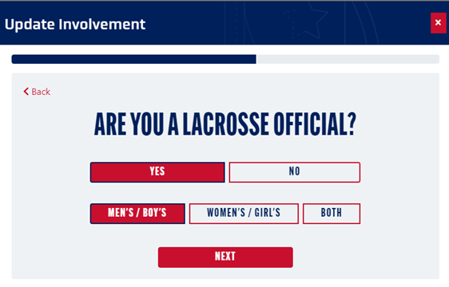

    - Once “Next” has been selected your “USER PROFILE” will reappear like the one below and “LACROSSE INVOLMENMT” show the areas that you are involved in.

Note for returning users: The E-Learning button is gone and now to access the classes you need to select Transcript.

- To access the base level courses, select “TRANSCRIPT” to begin your eLearning journey.

  - When “MY TRANSCRIPT” has been selected the dashboard below will appear. Select “BOYS OFFICIALS ANNUAL CERTIFICATION”.

  - When “BOYS OFFICIALS ANNUAL CERTIFICATION” has been selected the courses, you need to take will be listed. They will need to be taken in the order listed from top to bottom (see below).
    - eLearning Users Guide (Optional).
    - Boys Officials - Rules and Penalties Course (must be taken one time).
    - Boys Officials – Professional Development Course (must be taken annually).
    - Take one of the 3 Tests that are listed.
      - Boys Officials – 2024 NFHS Rules Exam
      - Boys Officials – 2024 Youth Rules Exam
      - Boys Officials – 2024 College Rules Exam

  - There are 2 additional courses that you can take they are the “BOYS OFFICIALS ADVANCED MODULE” and the “BOYS OFFICIALS APPRENTICE MODULE”. Both Modules are optional and not mandatory. Additionally, per USAL they will cost $35 per Module.

